**Spring MVC App Architecture**

**Basic Spring Controller**:

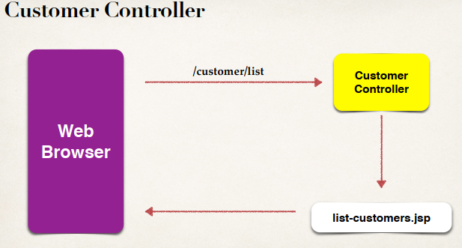

**Test MVC Controller**:

Create controller “**CustomerController.java**” class inside “**com.odduu.ruhul.controller**” package.

**File:** **CustomerController.java**:

**package** com.odduu.ruhul.controller;

**import** org.springframework.stereotype.Controller;

**import** org.springframework.ui.Model;

**import** org.springframework.web.bind.annotation.RequestMapping;

@Controller

@RequestMapping("/customer")

**public** **class** CustomerController {

@GetMapping("/list")

**public** String listCustomers(Model theModel) {

**return** "list-customers";

}

}

**View Page**:

Create view page “**list-customers.jsp**” inside “**WEB-INF/view**”

**File: list-customers.jsp**:

<!DOCTYPE html>

<html>

<head>

<title>List Customers</title>

</head>

<body>

<h2>List-Customer page for manage customer</h2>

<body>

</html>

Now if we run the page, we will get error. In the browser pass “**/customer/list**” and then we will get the output

List-Customer page for manage customer

**Diagram**:

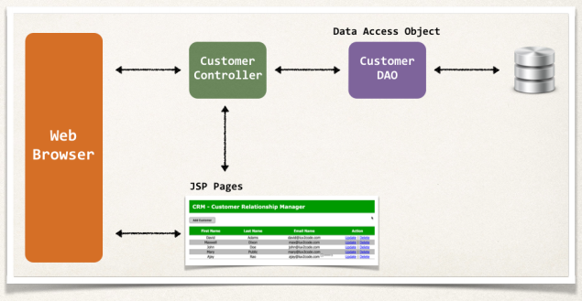

Spring MVC App Architecture